**Seasonality of Marketing Response Rates by Email and Catalogue**

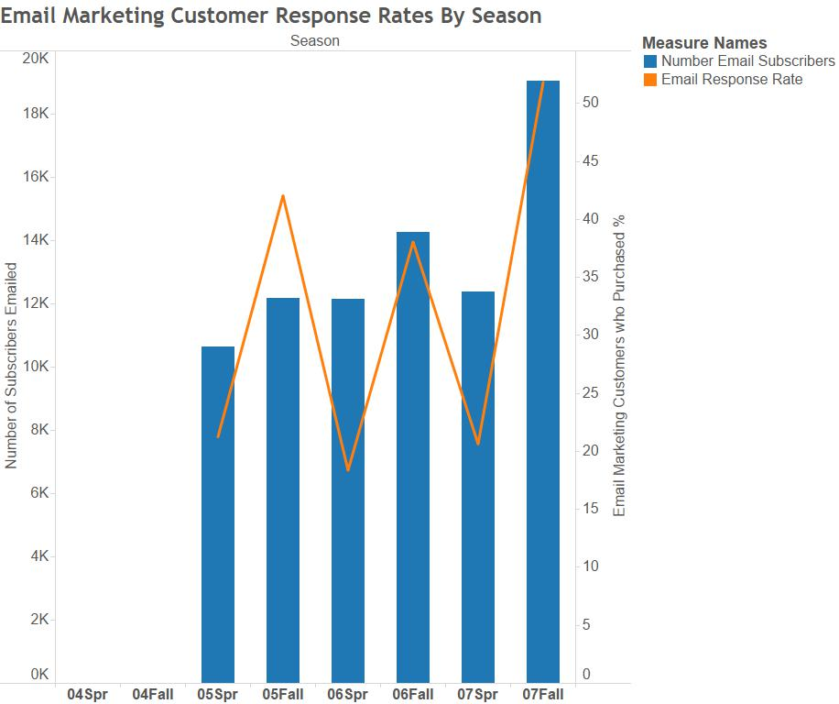

This chart shows the email marketing response rates for customers who were sent at least one marketing email in the season (lasting 6 months). They are counted as having responded if they have bought at least 1 item from the shop in that season through any channel (online order, in shop, or by phone).

The blue bar chart shows that the company have increased their number of email addresses to their subscription list. And the orange line peaking every Fall period, could suggest that response rates increase during the fall period. However, this seasonal spike might not be due to customer’s increased responsiveness, as customers might purchase items in Decemeber regardless of being sent emails.

Similar to the first chart, chart shows the catalogue marketing response rates for customers who were sent at least one catalogue in the season. They are counted as having responded if they have bought at least 1 item from the shop in that season through any channel.

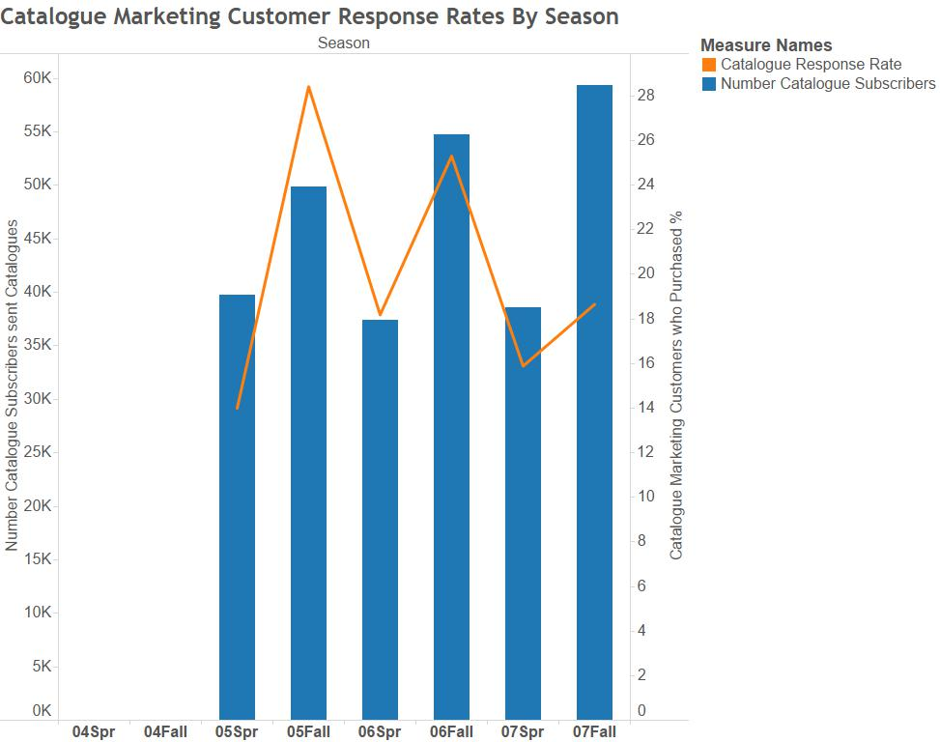

This chart is more interesting. The company sends out consistent numbers of catalogues during the spring season (flat level for ‘Spr’ bars). And they send more out every Fall period. However the catalogue response rates are falling every Fall, perhaps because a consistent consumer base who respond to catalogue marketing have been saturated in the number of catalogues being sent out, leading to a fall in the response rate. Or perhaps catalogue marketing is becoming less effective compared to other forms, say digital.